

NAME ______________________________________________

**REWIND AND REMEMBER #5 (Reg)**

Please show your work and turn this in on ____________________________ for a grade.

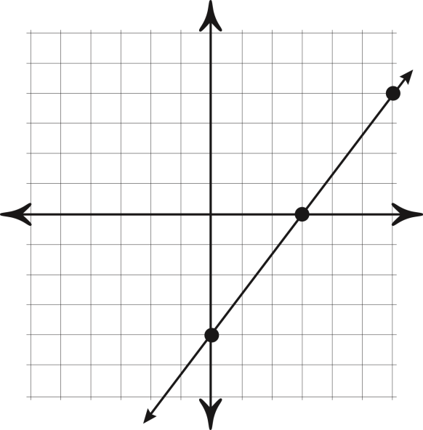

1) Find the slope of the line.

“rise over run”

2)

3)

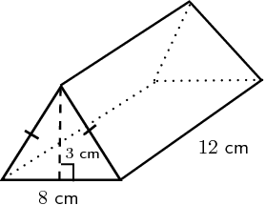

4) Find the volume of this triangular prism.

5) If x = -3, y = -6, then solve:

x – 2xy

6) The new Degas masterpiece purchased by the Museum of Fine Arts needs to be framed. If the rectangular picture measures 7b+2 wide and 5b+4 high, what is the perimeter of the painting? Give a simplified expression.

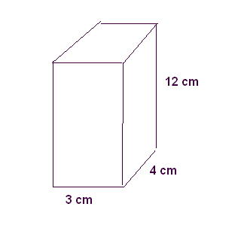7) What is the surface area of the rectangular prism below?

8) Find the next three numbers in the sequence:

5, -10, 20, _______, _________, __________

9) Use the distributive property and rewrite.

2a (a + c + 5)

MC900335710[1]10) Find the total carpeting bill to cover an 18 ft x 24 ft living room if the price is $17.00 per square foot. (You may use a calculator for this problem only.)