

NAME ______________________________________________

**REWIND AND REMEMBER #5 (Accelerated)**

Please show your work and turn this in on ____________________________ for a grade.

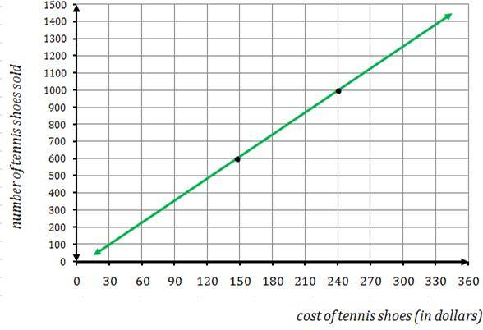

1) Find the slope of the line.

“rise over run”

1. 2) In the figure to the right, what is the value of x?

60°

120

***x***

3)

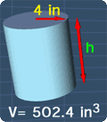MC900335710[1]

4) Find the height of this cylinder.



5) If x = -3, y = -6, then solve:

x – 2xy

6) The new Degas masterpiece purchased by the Museum of Fine Arts needs to be framed. If the rectangular picture measures 7b+2 wide and 5b high, what is the perimeter and area of the painting? Give a simplified expression.

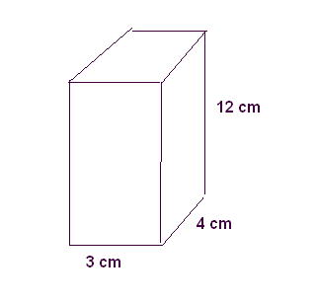7) What is the surface area and volume of the rectangular prism below?

8) Find the next three numbers in the sequence:

1, 8, 27, 64, _________, ___________, __________

9) Use the distributive property and rewrite.

-2a (a - c + 5 - a)

MC900335710[1]10) Find the total carpeting bill to cover an 18 ft x 24 ft living room if the price is $17.00 per square foot. (You may use a calculator for this problem only.)