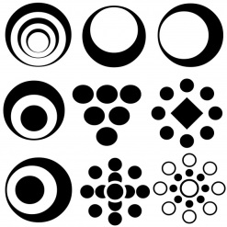
Name _________________________
Answer the following questions using 3.14 for pi.
1) Find the circumference if the area of a circle is 78.5 cm².

2) Find circumference if the area of circle is 314 ft².

3) Find circumference if the area of a circle is 153.86 ft².

4) Find area if circumference is 50.24 ft.

5) Find the area of a circle if the circumference is 62.8 cm.

